Name: _______________ Date: ________ Period: ____
P. Sci. Unit 4 (Ch. 15 & 16) Energy Review

Show ALL calculations on a separate piece of paper.

Chapter 15

- Define work:
- Define energy:
- Energy is measured in _____________.
- Give an example for each of the following types of energy
  - Kinetic ________________
  - Gravitational Potential ________________
  - Elastic Potential ________________
  - Chemical Potential ________________
  - Mechanical ________________
  - Thermal ________________
  - Nuclear ________________
  - Electromagnetic ________________
  - Electrical ________________
- Energy in the form of motion is ____________ energy.
- A rock at the edge of a cliff has _________ energy because of its position.
- Energy that is stored is ________ energy.
- Energy stored in food you eat is _________energy
- _________ energy is the total potential and kinetic energy in a system.
- _________ energy is stored in a stretched rubber band.
- A book sitting on a shelf has _________ _________ energy.
- Gravitational potential energy depends on _______, _______, and _______
- The primary source of the sun's energy is ________.
- A pendulum is swinging back and forth, starting at point A and ending at point E as shown in the image below. At what point(s) is the pendulum’s:
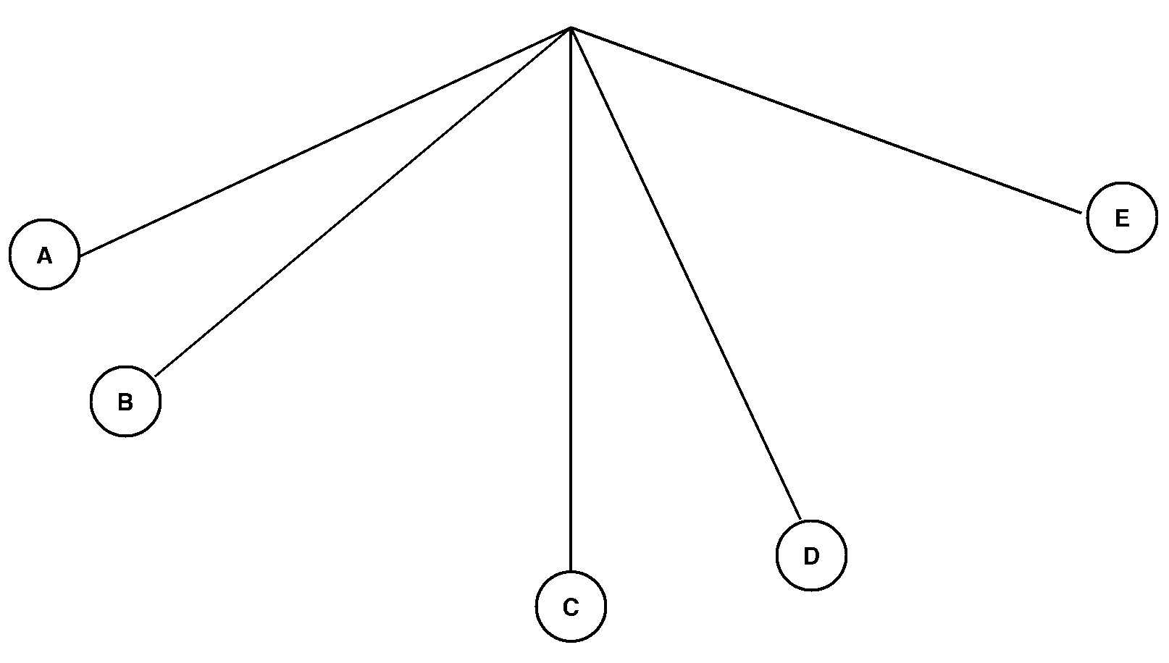
  - Kinetic energy decreasing ___
  - Kinetic energy increasing ___
  - Kinetic energy the HIGHEST __
  - Kinetic energy the LOWEST __
  - Potential energy decreasing ___
  - Potential energy increasing ___
  - Potential energy the HIGHEST _
  - Potential energy the LOWEST _
- The law of conservation of energy states that: ____
- Increasing the speed of an object (increases / decreases / does not affect) its potential energy.
- The SI unit for energy is the ________.
- A bus engine transfers chemical potential energy into ________ energy so that the bus moves.
- According to the Law of Conservation of Energy, the total amount of energy in the universe _________________________________.
- On a swing your potential and kinetic energies change, but your ________ ________ energy does not.
- When you move your hand or foot, your body has converted potential energy into ________ energy.

Problems
- What is the gravitational potential energy of a 55 kg box that is 8.0 m above the ground?
- A medicine ball has a mass of 5 kg and is thrown with a speed of 2 m/s. What is its kinetic energy?
- An object has a kinetic energy of 810 J after falling a certain distance. If the mass of the object is 20 kg, what is the speed of the object at this time?
- A ball has 100 J of potential energy when it is on a shelf.
  - Explain what happens to the potential energy and the kinetic energy as the ball falls.
  - Find the amount of kinetic energy the ball has at the instant it hits the floor.
- An 18-kg bicycle carrying a 62-kg girl is traveling at a speed of 7 m/s. What is the kinetic energy of the girl and bicycle?
- A 90-kg ceiling light is suspended 4 m above the floor. What is its gravitational potential energy?
- Using the image to the right label the points where :
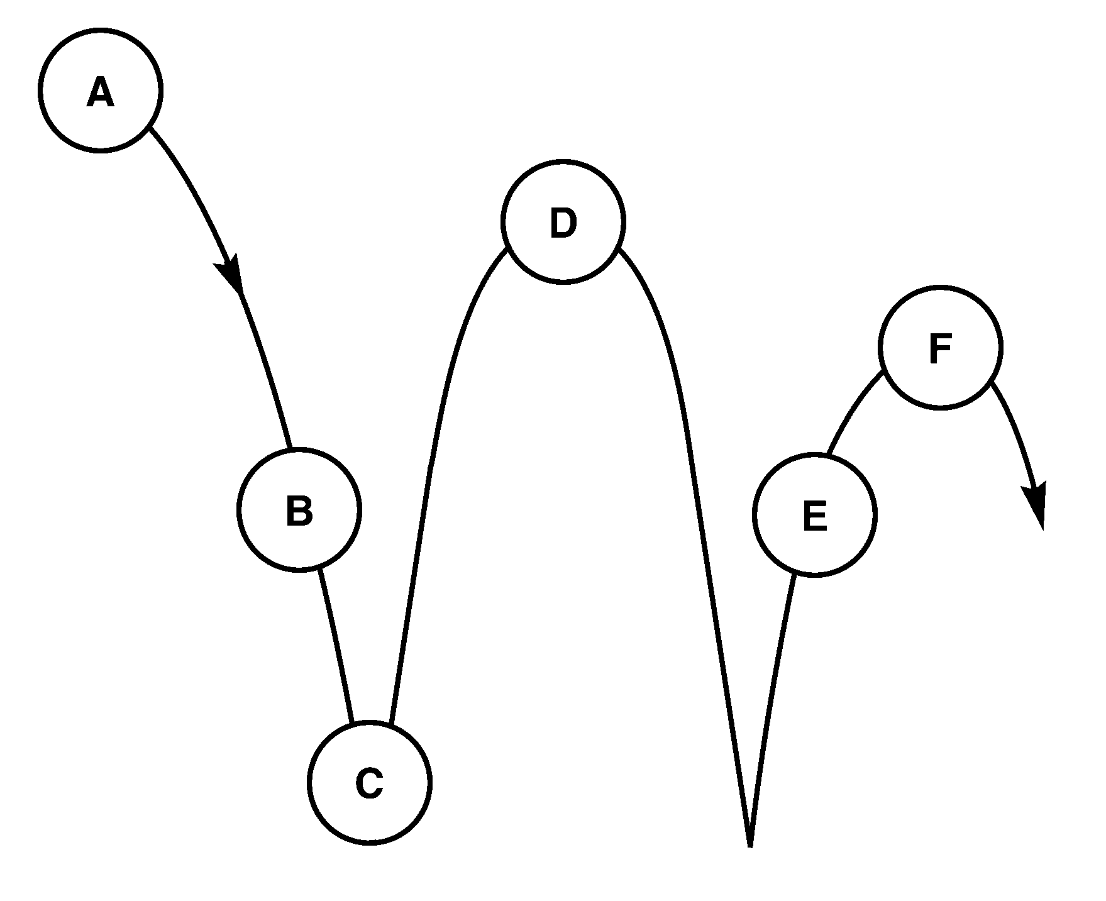
  - ___ Potential energy is the greatest.
  - ___ Kinetic energy is the greatest.
  - ___ Where BOTH are present.

Chapter 16

- What is related to the average kinetic energy of the particles in that object?
- As the temperature of mercury inside the thermometer increases, its volume ________.
- Energy is transferred as heat from a substance at (low / high) temperature to a substance at (low / high) temperature.
- Heating by convection can occur through (solids / liquids / gases).
- ________ is the only method of energy transfer that can take place in a vacuum.
- ________ is the only method of energy transfer that takes place in a fluid.
- ________ is the only method of energy transfer that requires contact of the objects.
- Heat is the transfer of thermal energy because of a ______ difference.
- A good insulator is a ________ conductor.
_________________________________________
Specific Heats at 25K
Substance | c (j/kg•K) | Substance | c (j/kg•K)
Water (liquid) | 4186 | Copper | 385
Steam | 1870 | Gold | 129
Ammonia (gas) | 2060 | Iron | 449
Ethanol (liquid) | 2440 | Mercury | 140
Aluminum | 897 | Lead | 129
Carbon (graphite) | 709 | Silver | 234

- Does it take more energy as heat to raise the temperature of water by one degree than to raise the temperature of steam by the same amount? Explain.

- Using the table, determine which substance can absorb the most energy in a temperature increase of 1K. ________________
- Which substance has a specific heat approximately 10 times greater than the specific heat of silver? ________________
- The temperature of 1.5 kg of ethanol is 37 K. What will the final temperature be if 80,000 J of energy as heat is added to the ethanol?

- 10 kg of a substance underwent a 3 K change in temperature when 11,500 J of energy as heat was added to the substance. What is the substance?
- What is –175ºC on the Kelvin scale? ________
- As the kinetic energy of the molecules in a substance increases, the ________ increases.
- The transfer of energy by the movement of fluids or gases with different temperatures is called ________.
- Energy from the sun reaches Earth by ________.
- Convection currents rise in air because ____________________________.
- Which method of energy transfer does not involve movement of matter? __
- How much heat energy will cause the temperature of 7 kg of iron to increase its temperature by 15 K? The specific heat of iron is 449 J/kg·K.

- A cold-blooded reptile basks on a warm rock in the sun. Its body is warmed by ________.
- The temperature of a substance increases by 3 K when 1635 J is added to a 2 kg quantity of the substance. What is the specific heat of the substance?

- How many kilojoules of heat must be transferred to a 670-g aluminum pan to raise its temperature from 32◦C to 250◦C? The specific heat of aluminum is 0.96 J/g·◦C.

- ________ is a measure of the average kinetic energy of all the particles within an object.
- The energy transferred between the particles of two objects because of the temperature difference between the two objects is called ________.
- ________ is the energy transfer as heat between particles as they collide within a substance or between two objects in contact.
- ________ is the transfer of energy by the movement of fluids with different temperatures.
- The movement of a gas or liquid due to expansion and contraction caused by temperature differences within the fluid is called a ________.
- The transfer of energy as waves moving through space is called ____
- A(n) ________ is a material through which energy can be easily transferred as heat.
- A(n) ________ is a material that is a poor energy conductor.
- Define specific heat:

